**Introduction to Linux**

**What is Linux?**

**LINUX** is an operating system or a kernel distributed under an open-source license. Its functionality list is quite like UNIX. The kernel is a program at the heart of the Linux operating system that takes care of fundamental stuff, like letting hardware communicate with software.

## Why do you need an OS?

Every time you switch on your computer, you see a screen where you can perform different activities like write, browse the internet or watch a video. What is it that makes the computer hardware work like that? How does the processor on your computer know that you are asking it to run a mp3 file?

Well, it is the operating system or the kernel which does this work. So, to work on your computer, you need an [Operating System (OS)](https://www.guru99.com/os-tutorial.html). In fact, you are using one as you read this on your computer. Now, you may have used popular OS’s like Windows, Apple OS X, but here we will learn introduction to Linux operating system, Linux overview and what benefits it offers over other OS choices.

## Who created Linux?

Linux is an operating system or a kernel which germinated as an idea in the mind of young and bright **Linus Torvalds** when he was a computer science student. He used to work on the **UNIX OS (proprietary software)**and thought that it needed improvements.

However, when his suggestions were rejected by the designers of UNIX, he thought of launching an OS which will be **receptive to changes, modifications suggested by its users**.

## Benefits of Linux

Linux OS now enjoys popularity at its prime, and it’s famous among programmers as well as regular computer users around the world. Its main benefits are –

It offers a **free operating system**. You do not have to shell hundreds of dollars to get the OS like Windows!

* Being open-source, anyone with programming knowledge can modify it.
* It is easy to learn [Linux](https://www.guru99.com/unix-linux-tutorial.html) for beginners
* The Linux operating systems now offer **millions of programs/applications and Linux softwares to choose from**, most of them are free!
* Once you have Linux installed you no longer need an antivirus! Linux is a highly secure system. More so, there is a global development community constantly looking at ways to enhance its security. With each upgrade, the OS becomes more secure and robust
* Linux freeware is the OS of choice for Server environments due to its stability and reliability (Mega-companies like Amazon, Facebook, and Google use Linux for their Servers). A Linux based server could run non-stop without a reboot for years on end

## What is Unix ?

The Unix operating system is a set of programs that act as a link between the computer and the user.

The computer programs that allocate the system resources and coordinate all the details of the computer's internals is called the **operating system** or the **kernel**.

Users communicate with the kernel through a program known as the **shell**. The shell is a command line interpreter; it translates commands entered by the user and converts them into a language that is understood by the kernel.

* Unix was originally developed in 1969 by a group of AT&T employees Ken Thompson, Dennis Ritchie, Douglas McIlroy, and Joe Ossanna at Bell Labs.
* There are various Unix variants available in the market. Solaris Unix, AIX, HP Unix and BSD are a few examples. Linux is also a flavor of Unix which is freely available.
* Several people can use a Unix computer at the same time; hence Unix is called a multiuser system.
* A user can also run multiple programs at the same time; hence Unix is a multitasking environment.

**TASK-1**

Practice the following commands in UNIX environment

1. cp b) rm c) mv d) chmod e) ps f) kill

**Touch command:**

Touch command is a way to create empty files (there are some other mehtods also). You can update the modification and access time of each file with the help of touch command.

1. touch **<filename>**

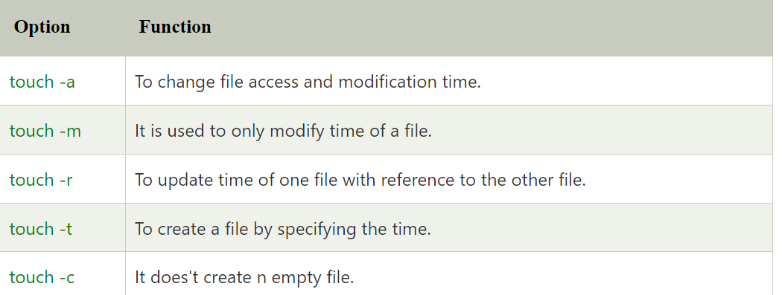

**Cat Command:**

The cat command is perhaps the most commonly used Unix command. It is derived from catenate – which describes the process of connecting things.

**The cat command is a filter that can be used for multiple purposes:**

1. Display the contents of text files.
2. Copy text files into a new file.
3. Append a text file to the end of another text file.
4. **Cat Command Syntax:**
5. cat [options] [files]
6. The cat command becomes a very powerful tool when combined with the Unix shell’s input and output redirection symbols:
7. cmd > file.txt: the “>” symbol redirects the stdout stream from the command to replace the contents of the specified file. The file will be created if it doesn’t exist, or its contents will be replaced if it does.
8. cmd >> file.txt: the “>>” symbol redirects the stdout stream from the command to append to the contents of the specified file. The file will be created if it doesn’t exist, or the new contents will be appended to the same file if it does.

**Examples:**

**List contents of file1 on stdout**

$ cat file1

**List the contents of file1 and file2 together on stdout**

$ cat file1 file2

**Copy contents of file1 and file2 to file3**

$ cat file1 file2 > file3

**Append contents of file1 and file2 to file4**

$ cat file1 file2 >> file4

If no filename is provided to the command, or if the file name is “-“, it reads the input text from stdin. This can be used to populate the contents of the file from the command prompt.

**Example:**

$ cat > file1

Hello

World

^D

In this example, the command reads its input from the terminal, and writes the output to the file “file1”. The user can enter their text line by line and terminate the input with the “^D” character that indicates end-of-file.

**The cat command also supports the following options:**

* cat -n: number the output lines.
* cat -s: suppress repeated output lines that are empty.

**CP Command:**

Use the cp command to create a copy of the contents of the file or directory specified by the SourceFile or SourceDirectory parameters into the file or directory specified by the TargetFile or TargetDirectory parameters.

cp' means copy. 'cp' command is used to copy a file or a directory.

To copy a file into the same directory syntax will be,

1. cp **<existing** file name**>** **<new** file name**>**

$cp: used for copying files.

Syntax: $cp [options] source_file destination-file

Example: $cp f1 f2 OUTPUT: $cat f1

This is GRIET

$cat f2 This is GRIET

It will copy the contents of f1 to f2

Options: a)-f: Force copy by removing the destination file if needed.

Syntax: $cp -f source_file destination-file

Example:$cp -f f1 f2

OUTPUT:$cat f1 This is CSE

$cat f2 This is GRIET

b)-i: Ask the confirmation to overwrite.

Syntax: $cp -i source_file destination-file

Example:$cp -i f1 f2

c)-b:It creates backup files before overriding.

2 Syntax: $cp -b source_file destination-file

Example:$cp -b f1 f2

**$rm: Used to remove files (or) directories**

Syntax: $rm [options] filename

Example:$rm f1

OUTPUT: f1 is deleted

Options: a)-f: ignores non existing files, never prompt

Syntax: $rm -f filename Example: $rm -f myfile.txt

OUTPUT:Removes file myfile.txt

3 b)-r: Removes all files in directory and directory itself

Syntax: $rm -r filename

Example: $rm -r mydirectory

OUTPUT: Removes directory mydirectory and all files in it.

c)-i: prompts before every removal.

Syntax: $rm -i filename

Example: $rm -i bak.c

**MV Command:**

$mv: mv stands for move.

mv is used to move one or more files or directories from one place to another in file system like UNIX. It has two distinct functions:

1. It rename a file or folder.

(ii) It moves group of files to different directory. No additional space is consumed on a disk during renaming. This command normally works silently means no prompt for confirmation.

Syntax: mv [Option] source destination.

**Options:**   
 **1. -i (Interactive):** Like in [cp](https://www.geeksforgeeks.org/cp-command-linux-examples/), the -i option makes the command ask the user for confirmation before moving a file that would overwrite an existing file, you have to press **y** for confirm moving, any other key leaves the file as it is. This option doesn’t work if the file doesn’t exist, it simply rename it or move it to new location.

1. **-f (Force):** **mv**prompts for confirmation overwriting the destination file if a file is**write-protected.**The **-f** option overrides this minor protection and overwrites the destination file forcefully and deletes the source file
2. **-n (no-clobber):** With **-n** option, **mv** prevent an existing file from being overwritten.

**4. -b(backup):** With this option, it is easier to take a backup of an existing file that will be overwritten as a result of the **mv**command. This will create a backup file with the tilde character(~) appended to it.

**5.–version:** This option is used to display the version of **mv**which is currently running on your system.

**$chmod command:**

To change directory permissions in Linux, use the following:

1. chmod +rwx filename to add permissions.

2. chmod -rwx directoryname to remove permissions.

3. chmod +x filename to allow executable permissions.

4. chmod -wx filename to take out write and executable permission

**$ps(Process Status):** This command is used to display the attributes of a process.

Syntax: $ps

Example: $ps

Options: -f: detailed listing which shows parent of every process,use(-f)->(full) option.

Example: $ps –f

-u:it displays processes of a user.

Example: $ps –u sumit

-a: displaying all user processes.

Example: $ps –a

**$kill:** This command is used to kill the process i.e; stop or terminate a process.(by administrator)

Syntax: $kill<pid>

Example: $kill 644